ADDING COMMITS WITH MEANINGFUL MESSAGES
When any changes made to a repository, those updates must be ‘committed’ to save them.
- On GitHub, ‘Commit changes…’option appears on top left-hand side. Click on ‘Commit changes’ to proceed.

After clicking, the following window appears
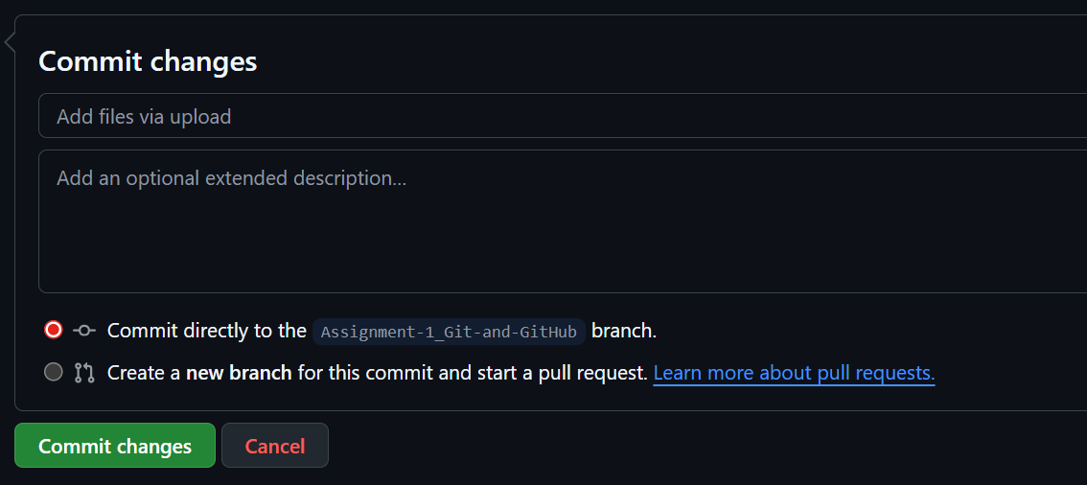
- In the first text box – briefly add what changes were made

- In the second text box, add brief explanation of the changes made for clarity and help with future reference.

- Now choose where the changes should be applied – on the main or to a branch.

- Finally, click on ‘commit changes’ to complete the process.


